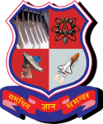A V PAREKH TECHNICAL INSTITUTE

TAGORE ROAD, RAJKOT

CERTIFICATE

This is to certify that the Project report, submitted along with the project entitled (Project Title) has been carried out by (Name of Team Member)(Enrolment Number) under my guidance in partial fulfilment for the Diploma in Computer Engineering 5th Semester of Gujarat Technological University, Ahmadabad during the academic year 2020-21. These students have successfully completed Project-1 activity under my guidance.

Internal Guide Head of the Department